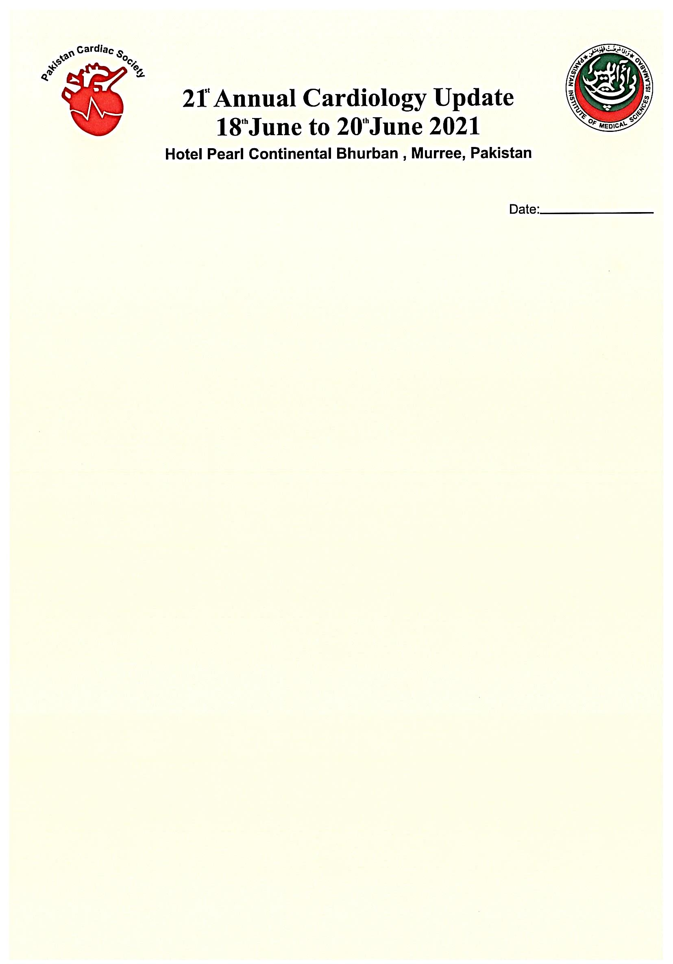

Dear Sir/Madam

We, the organizing committee, on behalf of Pakistan Cardiac Society invites you to participate in 21st Annual Cardiology Update 2021 which is to be held at PC Bhurban, Murree on 18th to 20th June 2021.

This year’s theme is “Updates on use of antithrombotic/anticoagulants in cardiovascular diseases”.

This year conference will be Hybrid program, and will be held strictly according to COVID-19 SOPS.

Faculty members, cardiologists, cardiac surgeons, fellows and allied are invited to participate as delegates, speakers and panel of experts. Three days program starting from 18th to 20th June will cover most aspects of cardiovascular diseases.

Speakers are invited to submit their abstracts on various talks on this theme. Further, dedicated sessions will be held on interventional cardiology, ECG/Electrophysiology/heart failure, arrhythmia and updates on cardiac surgery advancement in CAD management, structural heart diseases and their management.

Online speakers, moderators and panel of experts will have interactive sessions along with onsite presenters and audience.

Early response of participants from different countries / cardiac societies will enable us to make a perfect hybrid program possible. We will have online registration, managed by a professional company Further details will be shared on conference website [www.21stcardiologyupdate.com](http://www.21stcardiologyupdate.com).

We are looking forward for your active participation to make this event a great success in difficult time of COVI-19 pandemic. We are working hard to make perfect arrangements for Hybrid/virtual sessions.

We are honored to host the cardiology community at PC Bhurban Murree and wish you a safe

and comfortable stay.

**Akhtar Ali Bandeshah Muhammad Naeem Malik**   
 **Convener Patron**

**CONFERENCE SECRETARIATE  
Department of Cardiology  
Pakistan Institute of Medical Sciences, Islamabad  
Ph: # +92-51-9260330 Email:** [**pimscardiologygupdate@yahoo.com**](mailto:pimscardiologygupdate@yahoo.com) **Whatsapp Group: cardiology update, whatsapp # +92 321 5034320**